**Example2: Stored Procedures**

**Scenario1:** PL/SQL procedure block for Monthly interest processing for savings accounts

**Objective:** Create a stored procedure block processMonthlyInterest to calculate and update the balances of all the savings accounts by applying 1% interest rate to the current balance.

**Assumptions for Table Creation:**

* Table: accounts
* Columns: account_id, account_type, balance
* Savings accounts are identified with account_type = ‘SAVINGS’

**Procedure Logic:**

* Firstly, loop through the accounts table with account_type = ‘SAVINGS’.
* Then, for each calculate the balance i.e.

balance * 1.01

* Finally update the account with new balance.

**Construction of stored procedure PL/SQL block:**

monthly_interest.sql

|  |
| --- |
| CREATE TABLE accounts (  account_id NUMBER PRIMARY KEY,  account_type VARCHAR2(20),  balance NUMBER  );  INSERT INTO accounts VALUES (1, 'SAVINGS', 1000);  INSERT INTO accounts VALUES (2, 'CURRENT', 2000);  INSERT INTO accounts VALUES (3, 'SAVINGS', 1500);  INSERT INTO accounts VALUES (4, 'SAVINGS', 3000);  CREATE OR REPLACE PROCEDURE ProcessMonthlyInterest  IS  BEGIN  UPDATE accounts  SET balance = balance * 5  WHERE account_type = 'SAVINGS';  dbms_output.put_line ('balances updated');  END;  /  BEGIN  ProcessMonthlyInterest;  END;  /  select * from accounts where account_type = 'SAVINGS'; |

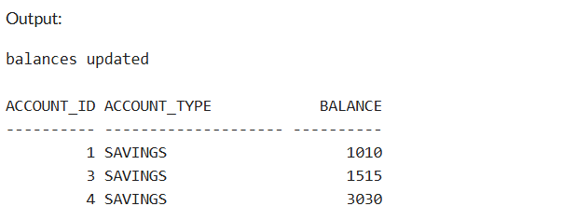

**Scenario2:** Employee Bonus Scheme for employees based on Department

**Objective:** To create a store procedure program i.e. updateEmployeeBonus to increase the salary of employees in a specific department by bonus percentage.

**Assumptions for Table Creation:**

* Table: Employees
* Columns: emp_id, dept_id, salary.
* Inputs of table:
* update_dept_id: Department to update
* update_bonus: Bonus percentage

**Logic of Procedure:**

* The parameters are dept_id and bonus_percentage.
* Calculate: updated_salary = salary + (salary * bonus / 100)

The updated salary is to be calculated for each department.

**Construction of PL/SQL procedure block:**

emp_bonus.sql:

|  |
| --- |
| CREATE TABLE employees (  emp_id NUMBER PRIMARY KEY,  dept_id NUMBER,  salary NUMBER  );  INSERT INTO employees VALUES (101, 10, 50000);  INSERT INTO employees VALUES (102, 20, 60000);  INSERT INTO employees VALUES (103, 10, 55000);  INSERT INTO employees VALUES (104, 30, 70000);  CREATE OR REPLACE PROCEDURE updateEmployeeBonus (  update_dept_id IN NUMBER,  update_bonus IN NUMBER  )  IS  BEGIN  UPDATE employees  SET salary = salary + (salary * update_bonus / 100)  WHERE dept_id = update_dept_id;  DBMS_OUTPUT.PUT_LINE ('Bonus applied to department: ' || update_dept_id);  END;  /  SET SERVEROUTPUT ON;  BEGIN  updateEmployeeBonus (10, 10);  END;  /  SELECT * FROM employees; |

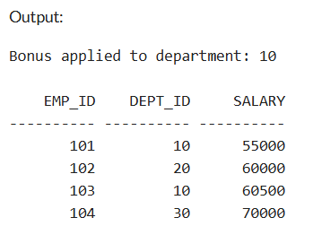

**Scenario3:** Transfer funds between the accounts.

**Objective:** To create a procedure block i.e. transferFunds to transfer funds between two accounts and make sure that the source account has sufficient balance before transfer.

**Assumptions for Table Creations**:

* Table: accounts
* Columns: acc_id, balance.
* Inputs to be taken:
* src_id: source account
* dest_id: Destination account/ Target account.
* amt: amount to transfer

**Procedure Logic:**

* Initially, fetch the existing balance of the source account.
* If balance is greater or equal to transfer / destination account then
* Subtract amount from source account
* Add the amount to the destination/target account.
* Or else,
* Raise an exception or display an error message.

**Construction of PL/SQL procedure block:**

transfer_funds.sql

|  |
| --- |
| CREATE TABLE accounts (  account_id NUMBER PRIMARY KEY,  balance NUMBER  );  INSERT INTO accounts VALUES (101, 5000);  INSERT INTO accounts VALUES (102, 3000);  INSERT INTO accounts VALUES (103, 1000);  select * from accounts;  CREATE OR REPLACE PROCEDURE transferFunds (  src_id IN NUMBER,  dest_id IN NUMBER,  amt IN NUMBER  )  IS  v_source_balance NUMBER;  BEGIN  SELECT balance INTO v_source_balance  FROM accounts  WHERE account_id = src_id;  IF v_source_balance >= amt THEN  UPDATE accounts  SET balance = balance - amt  WHERE account_id = src_id;  UPDATE accounts  SET balance = balance + amt  WHERE account_id = dest_id;  DBMS_OUTPUT.PUT_LINE ('Transfer of Rs. ' || amt || ' completed from ' || src_id || ' to ' || dest_id);  ELSE  RAISE_APPLICATION_ERROR (-20001, 'Maintain enough balance in source account.');  END IF;  END;  /  SET SERVEROUTPUT ON;  BEGIN  transferFunds (101, 102, 2000);  END;  /  SELECT * FROM accounts; |

Expected output:

